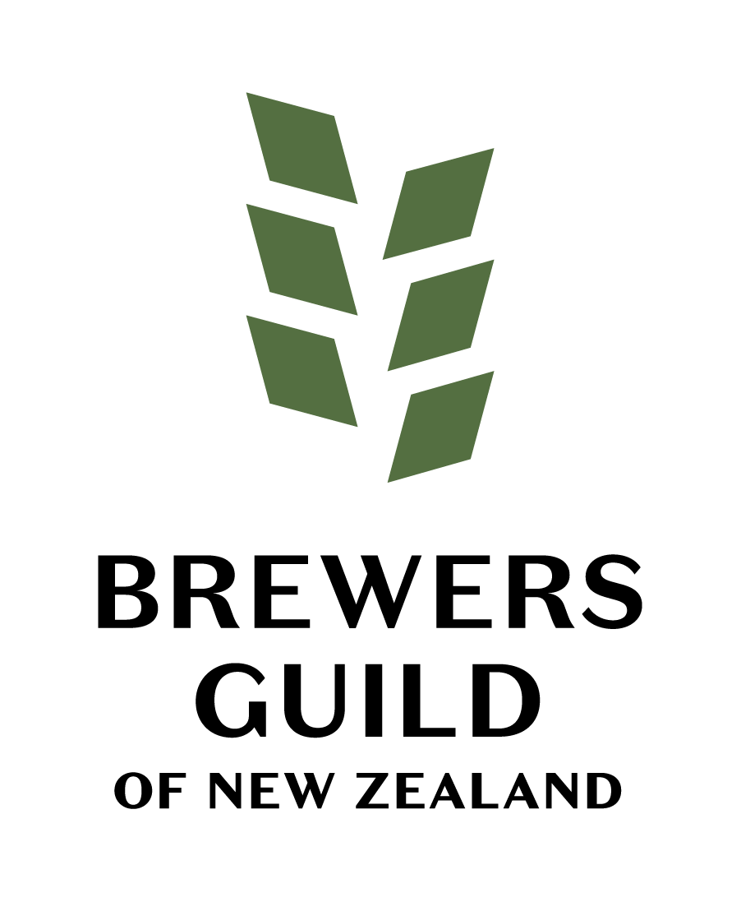

Minutes of the Nineteenth Annual General Meeting of the Brewers Guild of New Zealand Incorporated
11.30am on 2 August 2025 at Gladfield Malt, Dunsandel and via Zoom.

- Welcome & Opening Remarks
Chairman Brian Watson, formally opened the meeting at 11.51am confirming that the meeting was being held in person and via Zoom. Chairman, Brian Watson welcomed fellow board members and attendees. Mr Watson confirmed that there were no apologies received.
- Confirmation of Notice
Melanie Kees confirmed that notice of the Annual General Meeting had been circulated by email, announced on the Brewers Guild Website and shared via the newsletter and facebook to members – a formal note advising of the AGM date was announced to members on Friday 30 May 2025.

- Meeting Attendance
Melanie Kees confirmed that quorum for the meeting had been achieved through attendance. A list of meeting attendees and proxies is in Appendix A to these minutes.
There were no apologies received.

- Minutes of the 2024 AGM
The meeting considered the minutes of the 2024 Annual General Meeting of the Brewers Guild which had been circulated in advance of the meeting.
MOTION
‘That the Minutes of the 18th Annual General Meeting of the Brewers Guild of New Zealand held on 3 August 2024 be accepted as true and correct.’
Motion: Sebastian BMorley, Steam Brewing
Seconded: Heidi Crockett, Colab Brewing
APPROVED
- Chairman’s Report
Chairman Brian Watson, delivered a speech reflecting on what the Guild has achieved over the past 21 months. There were no questions following this.

- Financial Report
Board Member, Sebastian Burke spoke to the financial statements.
Mr Burke gave an overview of the performance report and confirmed that the financial reports had been circulated prior to the Annual General meeting. The 2024-25 year continued the trend of the year before with the guild posting a profit.
The 2024-25 year continued the trend of the year before with the guild posting a profit.
Following two years focusing on building both our community and our financial reserves, we started to reinvest in the Guild supporting our members while advocating for the industry.
With a solid foundation we continue to show positive financial results in what continues to be a challenging environment. Some keys points from the financial report:
A Modest Surplus Achieved - The Guild ended the year with a surplus of $12,750, staying in the black despite declining award entries and rising costs.
Revenue Down from Prior Year - Total revenue dropped from $575,572 (2023–24) to $490,216, mainly due to reduced income from entries and sponsorships.
Stable Operational Spending - Operating expenses held steady at $477,467, compared to $492,649 the previous year—demonstrating solid cost control.
Membership & Sponsorship Support Strong - Membership income remained consistent, and sponsors continued to back key events, reinforcing the Guild’s industry relevance.
Cash Position Strengthened - Ending cash balance increased to $338,203, a rise of nearly $46K, providing a healthy buffer for future initiatives.
Continued Compliance & Transparency - No audit was conducted (as per usual practice), and all financial reporting adhered to standards and legal requirements.
To note: The ‘related party transactions’ i.e. the Board are payments from those individuals/respective organisations to the Guild as membership fees not the other way around.
Mr Watson asked if there were any further questions around the EOY Financials, of which there were none.
MOTION
‘That the Financial Statements for the Brewers Guild of New Zealand for the Year Ended 31 March 2025 be accepted as true and correct.’
Motion: Dudley Haines, Invita
Seconded: Mark Limber, Two Thumb Brewing
APPROVED

- Election of Board
This year we received five nominations. There were 6 positions on the board, therefore those five nominees will automatically be appointed to the board with no vote required.
With one position remaining and as per the guild Rules, Sebastian Burke has offered to continue in his position which we have accepted.

I’d like to welcome back onto the board – Shane Morley, Alyssa Hodgson, Heidi Crockett, Jason Ray and Sebastian Burke. I am also pleased to welcome Gabi Michael to the board as a new board member and our first corporate member representative.

Please can I ask two members to move and second these board appointments.

MOTION
‘That the election results are accepted, and the new Directors for the Brewers Guild of New Zealand board are accepted’.
Motion: Tracy Banner, Sprig + Fern
Seconded: Alyssa Hodgson, Lion
APPROVED
- Presentation of the Strategy
Brian Watson and Vice-Chair Eddie Gapper presented the new 2025 – 2028 Guild strategy to the board. They explained the four pillars, the goals and success measures. There were no questions following the presentation.
- Adoption of the following motion – ‘to amend the bord member terms and tenure in the constitution’.
The Brewers Guild of New Zealand board proposes amending clauses 4.2 and 4.3 of its Constitution to:
1. Extend Board Member terms from two years to three years; and
2. Adjust the maximum consecutive service from three two-year terms (six years) to three three-year terms (nine years).
The motion was shared with members and voting took place via Election Buddy.
We can confirm that 96% of voters voted yes and the motion has been adopted.
The new constitution will be filed with the Societies Office.

- General Business & Close of Meeting
Mr Watson concluded the meeting by asking if there were any questions, of which there were none. There was also no further business so the meeting was closed at 12:12pm.

APPENDIX A – MEETING ATTENDANCE
NAME | BREWERY
Greig McGill | Brewaucracy
Pawel Lewandowski | Mount Brewing
Jesse Sigurdsson | Shining Peak
Kate McDonald | Wanaka Beerworks
Ralph Bungard | Three Boys
Andi Hickey | Beer Baroness
Joe Wood | Liberty
Hop Federation | Simon Nicholas
Hop Federation | Dean Hunter
Colab Brewing | Heidi Crokett
Colab Brewing | Martyn Crockett
Steam Brewing Company Ltd | Shane Morley
Steam Brewing Company Ltd | Craig Buddle
Steam Brewing Company Ltd | Christopher Ward
Steam Brewing Company Ltd | Simon Farrell
Good George Brewing | Brian Watson
Good George Brewing | Oli Bird
Good George Brewing | Aynslee Roger
Good George Brewing | Natalie Mora
Good George Brewing | Possible Alice Watson
Lion | Alyssa Hodgson
Volstead Brewing Co | Jason Ray
Altitude Brewing | Eddie Gapper
Sprig + Fern | Tracy Banner
Sprig + Fern | Daniel Tipping
Sprig + Fern | Chris Goff
Brave Brewing | Matt Smith
Brave Brewing | Gemma Smith
Brave Brewing | Kalynn Glasscock
Brave Brewing | Adam Lamberg
Asahi | Tina Panoutsos
Parrotdog Brewing | Matt Warner
Parrotdog Brewing | Paul Watson
Parrotdog Brewing | Ben Thomas
Parrotdog Brewing | Raeuben Glen
Parrotdog Brewing | Sam Stosser
Parrotdog Brewing | Ali Ali
Parrotdog Brewing | Tim Smith
Eruption Brewing | Scott Calvert
DNA Brewing | David Nicholls
DNA Brewing | Tommy Delahunty
DNA Brewing | Kim Nicholls
Sawmill | Rory Taylor
Sawmill | Russell Erskine
Sawmill | Tom Fleming
Sawmill | James Sutherland
Burkes Brewing Co | Sebastian Burke
Burkes Brewing Co | Jacinda Burke
Brew Moon Brewing Company | Dani Wild
Brew Moon Brewing Company | Oscar McCauley
Two Thumb Brewing Company | Mark Limber
Corporate Attendees
Invita NZ | Dudley Haines
Viniquip | Aaron O'Keeffe
Gladfield Malt | Doug Michael
Gladfield Malt | Gabi Michael

