1. **INCIDENTS, COMPLAINTS & RECALLS**

# Section 4.1 Incident / Non-Conformance Procedures

The purpose of this procedure is to capture and address any incident that could potentially, or has caused product to become non-conforming i.e., not safe (may cause illness or harm), or suitable (food meets customer expectations and does not contain anything unexpected or offensive).

Any staff member may action an investigation into an incident. The incident shall be recorded on the When Something Goes Wrong form (Form 8).

Instances for when this report would be used would include the following:

* Non-conforming raw materials in storage
* Non-conforming product in processing and/or finished product
* Equipment / plant failure that impacts on product quality and/or safety.

All non-conforming products shall be segregated from conforming product and clearly marked to identify it as non-conforming product until time of disposition.

As part of the investigation the manager must determine whether the non-compliance requires a trade or consumer recall (refer Section 4.3).

All staff shall be required to report non-conformances or any concerns regarding products to management as soon as practicable.

The reason for non-conformance shall be clearly documented and corrective action applied.

Instances of non-conforming product shall be communicated to the source of the issue and corrective action applied. This includes the raw material supplier.

Special Note: Food Regulations 2015, Regulation 80 – Breach of National Programme Must Be Reported

(1) The operator must report to the operator’s verification agency or verifier any breach of the national programme that results in food that—

(a) is not, or may not be, safe or suitable; and

(b) could cause an adverse or injurious effect on human life or public health.

(2) The operator must report the breach as soon as practicable after the operator becomes aware of it.

Records:

*Form 8: When Something Goes Wrong Form*

# Section 4.2 Customer Complaints

This procedure deals with any form of product complaint relating to the safety or suitability of the finished products.

It is the responsibility of the manager to ensure the complaint is documented on the Customer Complaint form (Form 7) or equivalent record system.

It is the responsibility of the manager to ensure all necessary corrective action and preventative action is carried out.

It is the responsibility of the manager to decide as to whether the nature of the complaint requires further investigation, notification to the Verifier (unsafe food may have been produced) and/or whether a trade or consumer recall is necessary.

The company manager is responsibility to ensure the investigation is carried out, the records are completed, and the completed Customer Complaints form together with other relevant documentation are filed.

The investigation should focus on factors contributing to the complaints including:

* Processes: review of relevant records.
* Premises: including relevant procedures e.g., cleaning, pest control and maintenance procedures.
* Personnel: review of relevant staff training/knowledge of processes and hygiene practices.

The Food Safety Programme shall be checked to ascertain if identified hazards from the investigation findings have been overlooked or control points omitted.

Records:

*Form 7: Customer Complaints Form*

# Section 4.3 Product Recall

A product recall is when unsafe or unsuitable product that has been distributed to other businesses and/or the consumer, is immediately withdrawn from sale to protect the consumer.

Product may need to be recalled if it:

* contains an undeclared allergen (e.g., Lactose (milk)),
* is contaminated with harmful microorganisms,
* is contaminated with harmful chemicals,
* is contaminated with physical matter such as glass or wood, or
* has been tampered with.

A recall may be required based on a customer complaint. In this instance, a customer complaint form will be completed.

In these instances, we need to assess the risk to consumers, and choose what to do:

* a **consumer-level** recall, which involves removing affected product from the supply chain and communicating to consumers; or
* a **trade-level** recall, which involves removing affected product from the supply chain; or
* no further action, other than to resolve the problem.

In the event of a product recall, the recall programme is controlled by the manager, or delegated employee of the business, and the system as defined in the food recall guidance prepared by the Ministry for Primary Industries (MPI) will be used (refer [www.mpi.govt.nz/food-business/food-recalls/](http://www.mpi.govt.nz/food-business/food-recalls/)).

**Recommended Recall Steps**

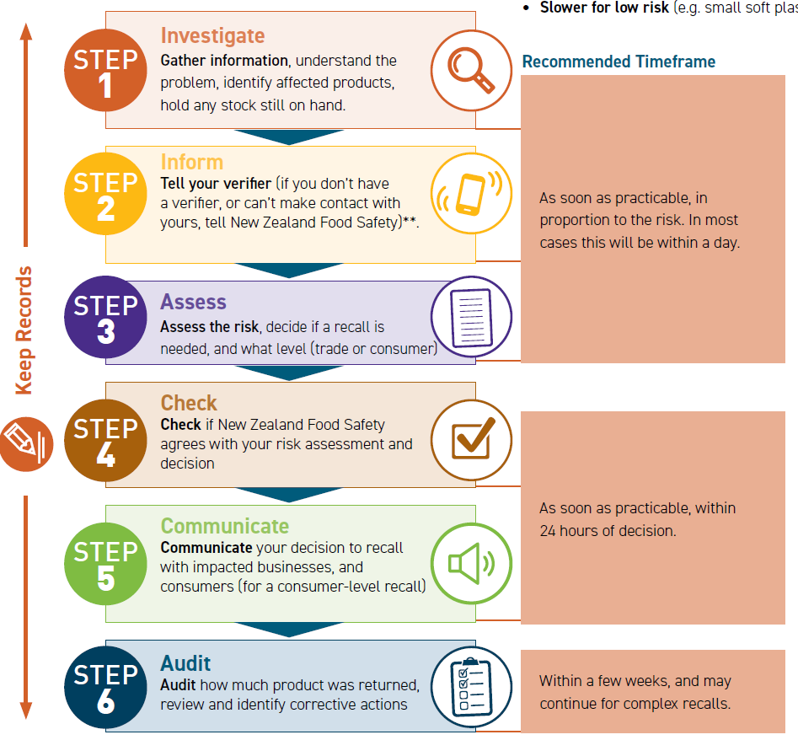

**Diagram reproduced from MPI Guidance Document - *Step-By-Step Food Recall Guidance for Food Businesses (April 2022)***

Refer [www.mpi.govt.nz/food-business/food-recalls/](http://www.mpi.govt.nz/food-business/food-recalls/) for latest guidance and record templates.

Note: You can contact New Zealand Food Safety anytime for help on:

0800 00 83 33 or [Food.Recalls@mpi.govt.nz](mailto:Food.Recalls@mpi.govt.nz).

A Simulation (Mock) Recall must be conducted at least annually to test the traceability and recall processes. Recall records must include a completed Food 'Recall Risk Assessment Form', 'Recall Audit Form' (or stock reconciliation information) and 'Simulated Recall Checklist' (optional).

Where the business subscribes to the GS1 Product Recall NZ system, communication to key customers e.g. retailers is also made through the GS1 portal. Refer to <https://www.gs1nz.org/services/product-recall/>

Records:

MPI Forms (Check current version is used):

*Food Recall Risk Assessment Form* (Mandatory)

*Recall Audit Form* (or other record of stock reconciliation)

*Simulated Recall Checklist*

# Recall Procedure Example

MPI (NZFS) have provided the following recall procedure, which you can adapt it for your business.

## Recall Objectives

[Business name] will carry out a recall to:

• Protect the health and safety of consumers

• Protect brand reputation

• Quickly stop distribution and sale of food found to have an issue

• Retrieve and dispose of recalled food items

• Find and correct things that caused the problem

## Recall Team – Management and Responsibilities

|  |
| --- |
| *Identify who is in your recall team. If you can, have a range of people in this team to represent the different aspects of your company. Each person should have a clear understanding on what they will do in a recall. When making up your team identify someone as the “recall coordinator”. This is the person who will have all the information available to pass onto the people who need it and will be the main contact for the recall.* |

The table below sets out key responsibilities for ________________________’s [business name] recall team members.

|  |
| --- |
| *If you have a small business, you may only have one or two people to cover these tasks. If your business is large there may be additional tasks and responsibilities to be outlined. You can fill in this table to record the person, task and contact for people in your recall team. Be sure to think about how you will contact people afterhours. There are extra spaces for you to detail any extra recall responsibilities.* |

|  |  |  |
| --- | --- | --- |
| **Name** | **Responsibility** | **Contact Information** |
|  | E.g., Overall decision-maker on whether a recall is needed | Number:  Email: |
|  | e.g., Act as the recall coordinator by managing communication with recall team members and other external parties | Number:  Email: |
|  | e.g., Manage consumer complaints  Plan for how to tell consumers about a recall | Number:  Email: |
|  | e.g., Make a distribution list identifying where all affected product has gone | Number:  Email: |
| [Add or remove rows as needed] |  | Number:  Email: |
| *[Name]* (Verifier) | E.g., Review if there is a potential food safety issue | Number:  Email: |
| New Zealand Food Safety | E.g., Update Ministry for Primary Industries recall information | 0800 00 83 33  [Food.Recalls@mpi.govt.nz](mailto:Food.Recalls@mpi.govt.nz) |

## Recall Steps

____________________ [*Business name*] will carry out the following tasks to decide if a recall is needed, and to carry out the recall.

|  |  |
| --- | --- |
| **Step** | **Task** |
|
|  | Record report of problem |
| **1** | **Investigate** |
|  | * Gather information about the problem |
|  | * Use records (e.g. production, inventory, sales and distribution) to identify affected products |
|  | * Use records (e.g. production, inventory, sales and distribution) to determine where all affected products are |
|  | * Put product in *[business’s]* control on-hold |
| **2** | **Inform** |
|  | * Prepare and send communications (e.g. email) to verifier: *[verifier name and contact]* and/or NZFS ([Food.Recalls@mpi.govt.nz/](mailto:Food.Recalls@mpi.govt.nz/) 0800 00 83 33) |
|  | * Optional: prepare precautionary communications (e.g. emails) to logistics providers, customers, suppliers, and brand owners |
| **3** | **Assess** |
|  | * Carry out a risk-assessment, NZFS recommends using the [Risk Assessment form](https://www.mpi.govt.nz/dmsdocument/50356-Food-recall-risk-assessment-form). |
|  | * Make a decision to recall (or no further action), the type of recall (e.g. consumer-level or trade-level) which products and batches are included, and record your justification. |
| **4** | **Check** |
|  | * Tell NZFS ([Food.Recalls@mpi.govt.nz](mailto:Food.Recalls@mpi.govt.nz/)/0800 00 83 33). Check your risk assessment and recall decision with NZFS by sending your risk assessment (e.g. email) and copy your verifier *[verifier name and contact]* |
| **5** | **Communicate** |
|  | If your recall is a consumer-level recall:   * Prepare a [point-of-sale notice](https://www.mpi.govt.nz/dmsdocument/22357-Food-recall-notice-template-General-products) (or [allergen point of sale notice](https://www.mpi.govt.nz/dmsdocument/22360-Food-recall-notice-template-Allergen-warning)) and check it with NZFS ([Food.Recalls@mpi.govt.nz/](mailto:Food.Recalls@mpi.govt.nz/) 0800 00 83 33), or NZFS can prepare one for you. |
|  | If your recall is a consumer or trade-level recall:   * Prepare and send communications (e.g. emails) notifying impacted businesses ([Example email](https://www.mpi.govt.nz/dmsdocument/50269-Food-Recall-Email-to-Businesses-Example)) |
|  | If your recall is a consumer-level recall:   * Prepare and release consumer communications (e.g. [media release](https://www.mpi.govt.nz/dmsdocument/50272-Food-Recall-Media-Release-Example), [social media release](https://www.mpi.govt.nz/dmsdocument/50281-Food-Recall-Social-Media-Notification-Example)) |
| **6** | **Audit** |
|  | * Collect reconciliation records:   + Amount of affected product produced/imported;   + Amount on hold;   + Other (E.g. staff sale, quality control samples, internet sales, export) (units);   + Amount claimed for by trade customers;   + Amount that was returned by trade customers;   + Amount that was returned by consumers;   + Amount unaccounted for. * Complete the [audit form](https://www.mpi.govt.nz/dmsdocument/50359-Food-recall-audit-form) and send it (E.g. email) to your case officer or NZFS ([Food.Recalls@mpi.govt.nz](mailto:Food.Recalls@mpi.govt.nz/)) with any attachments. * Review and identify corrective actions (if any), who will do them, and when. |

# Section 4.4 Reopening after a power cut or civil emergency

In the event of power cut or civil emergency (e.g., earthquake, flood etc.) it is important that the business is fully checked to ensure that safe food can once again be made. We consider the following points to ensure we cover these key elements before resuming production.

1. **Confirm the premises are structurally sound for producing food**

Once the building has formally been declared as safe, we confirm that any damage to food areas does not stop us from operating hygienically. Is there a chance that food will become contaminated, such as from leaking sewerage or damaged ceiling or wall claddings falling onto food? We make sure the services we need for power, water supply and drainage haven’t been damaged or weakened in the premises.

1. **Check that toilets and personnel hygiene facilities are working**

We make sure toilets for staff and customers are in working order. If a “boil water” notice is in effect, staff are required to wash hands using cooled boiled water or water treated with bleach or chlorine (5 drops of bleach to 1 litre of water); then use a hand sanitiser.

1. **Clean the premises thoroughly before use**

Areas used for food preparation are thoroughly cleaned be use and utensils sanitised before use, to ensure there is no risk to food safety.

1. **Confirm the water is safe to use**

If a “boil water” notice is in effect extra care is taken where water is used for hand washing or cleaning and the tank water may be utilised for these purposes. We will use a sanitiser after washing hands, especially if water is scarce. When the “boil water” notice has been lifted, we will run taps to check the water before we use it. If we notice anything unusual with the colour or cloudiness or smell, then we will contact our water supplier for advice. We will not use the water until our supplier has confirmed that it is okay.

1. **Check that ingredients are still safe to use**

We will check how long the chiller has been without power, product pH, taste may need to be rechecked.

Other foods, such as shelf-stable ingredients are checked for damage. These foods will be used as long as packaging is intact, and food is not exposed. Packaging may need to be cleaned before opening to prevent contamination of food. If in doubt, we will throw it out.

1. **Check the chiller is working**

Make sure the chiller has not been damaged and will work as intended.

1. **Ensure staff know what to do**

Prior to resuming production all staff are instructed on what they must do to produce safe food during/post an emergency, particularly if we have a disrupted clean water supply. It is vital hands and food contact surfaces are kept clean. If in any doubt about what we should do, we will contact the Environmental Health Officer at our local council

Records:

*Form 18: Reopening after a Power Cut or Civil Emergency Checklist*

Refer to: <https://www.mpi.govt.nz/food-business/food-safety-in-natural-disasters-and-emergencies-2/> for further information.